Experiment No. 3
Creating Transactions
Aim: Creating Transactions using Solidity and Remix IDE
Theory:
- Consider a smart contract for basic banking operations. This contract includes all of the functionalities and capabilities that Solidity presents. Also, it demonstrates about how to send ETH between any account and the contract developed (from an account to a contract or from a contract to an account) and how to restrict the people who can use the relevant function of the smart contract.

- Create a client object to keep the client’s information, which will join the contract by using the struct element. It keeps the client’s ID, address, and balance in the contract. Then we create an array in the client_account type to keep the information of all of our clients.

- Assign an ID to each client whenever they join the contract, so we define an int counter and set it to 0 in the constructor of the contract.

- Define an address variable for the manager and a mapping to keep the last interest date of each client. Since we want to restrict the time required to send interest again to any account, it’ll be used to check whether enough time has elapsed.

- In a smart contract, in order to restrict the people that can call the relevant method or to allow the execution of the method only specific circumstances. In these kinds of circumstances, the modifier checks the condition you’ve implemented, and it determines whether the relevant method should be executed.

- Before implementing all of the methods we need to organize the smart contract, we have to implement two modifiers. Both methods will check the people who call the relevant method and which of the modifiers is used. One of them determines whether the sender is the manager, and the other one determines whether the sender is a client.

- The fallback function is essential to making the contract receive ether from any address. The receive keyword is new in Solidity 0.6.x, and it’s used as a fallback function to receive ether. Since we’ll receive ether from the clients as a deposit, we need to implement the fallback function.

- The setManager method will be used to set the manager address to variables we’ve defined. The managerAddress is consumed as a parameter and cast as payable to provide sending ether. The joinAsClient method will be used to make sure the client joins the contract. Whenever a client joins the contact, their interest date will be set, and the client information will be added to the client array.
- The deposit method will be used to send ETH from the client account to the contract. We want this method to be callable only by clients who’ve joined the contract, so the onlyClient modifier is used for this restriction. The transfer methods belong to the contract, and it’s dedicated to sending an indicated amount of ETH between addresses. The payable keyword makes receipt of the ETH transfer possible, so the amount of ETH indicated in the msg.value will be transferred to the contract address.
- The withdraw method will be used to send ETH from the contract to the client account. It sends the unit of ETH indicated in the amount parameter, from the contract to the client who sent the transaction. We want this method to be callable only by clients who’ve joined the contract either, so the onlyClient modifier is used for this restriction. The address of the sender is held in the msg.sender variable.
- The sendInterest method will be used to send ETH as interest from the contract to all clients. We want this method to be callable only by the manager, so the onlyManager modifier is used for this restriction. Here, the last date when the relevant client takes the interest will be checked for all of the clients, and the interest will be sent if the specific time period has elapsed. Finally, the new interest date is reset for the relevant client into the interestDate array if the new interest is sent. The getContractBalance method will be used to get the balance of the contract we deployed.

// SPDX-License-Identifier: MIT

// BCT : Exp - 3
// Atharva Prashant Pawar (9427) - Comps-A [Batch-D]

pragma solidity ^0.8.0;

contract BankContract {
struct client_account{
int client_id;
address client_address;
uint client_balance_in_ether;
}
client_account[] clients;
int clientCounter;
address payable manager;
mapping(address => uint) public interestDate;

modifier onlyManager() {
require(msg.sender == manager, "Only manager can call this!");
_;
}

modifier onlyClients() {
bool isclient = false;
for(uint i=0;i<clients.length;i++){
if(clients[i].client_address == msg.sender){
isclient = true;
break;
}
}
require(isclient, "Only clients can call this!");
_;
}
constructor() {
clientCounter = 0;
}
// constructor() public{
// clientCounter = 0;
// }
receive() external payable { }
function setManager(address managerAddress) public returns(string memory){
manager = payable(managerAddress);
return "";
}
function joinAsClient() public payable returns(string memory){
interestDate[msg.sender] = block.timestamp;
clients.push(client_account(clientCounter++, msg.sender, address(msg.sender).balance));
return "";
}
function deposit() public payable onlyClients{
payable(address(this)).transfer(msg.value);
}
function withdraw(uint amount) public payable onlyClients{
payable(msg.sender).transfer(amount * 1 ether);
}
function sendInterest() public payable onlyManager{
for(uint i=0;i<clients.length;i++){
address initialAddress = clients[i].client_address;
uint lastInterestDate = interestDate[initialAddress];
if(block.timestamp < lastInterestDate + 10 seconds){
revert("It's just been less than 10 seconds!");
}
payable(initialAddress).transfer(1 ether);
interestDate[initialAddress] = block.timestamp;
}
}
function getContractBalance() public view returns(uint){
return address(this).balance;
}
}
Step 1: Create BankContract.sol and Compile the Smart Contract
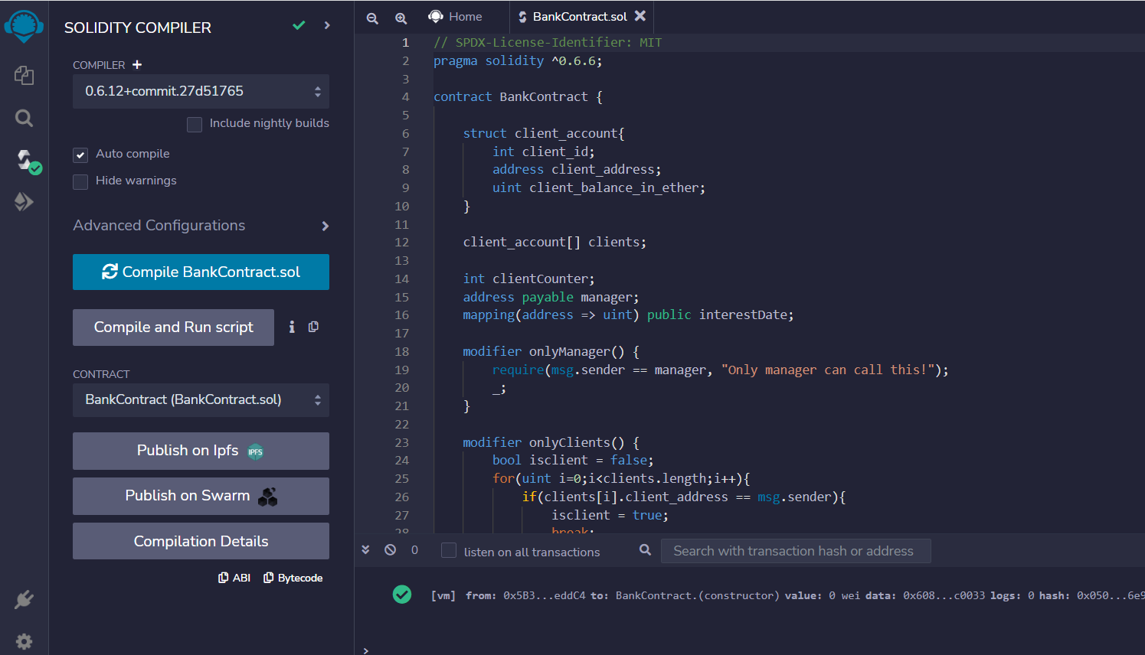
Step 2: Deploy the Smart Contract.
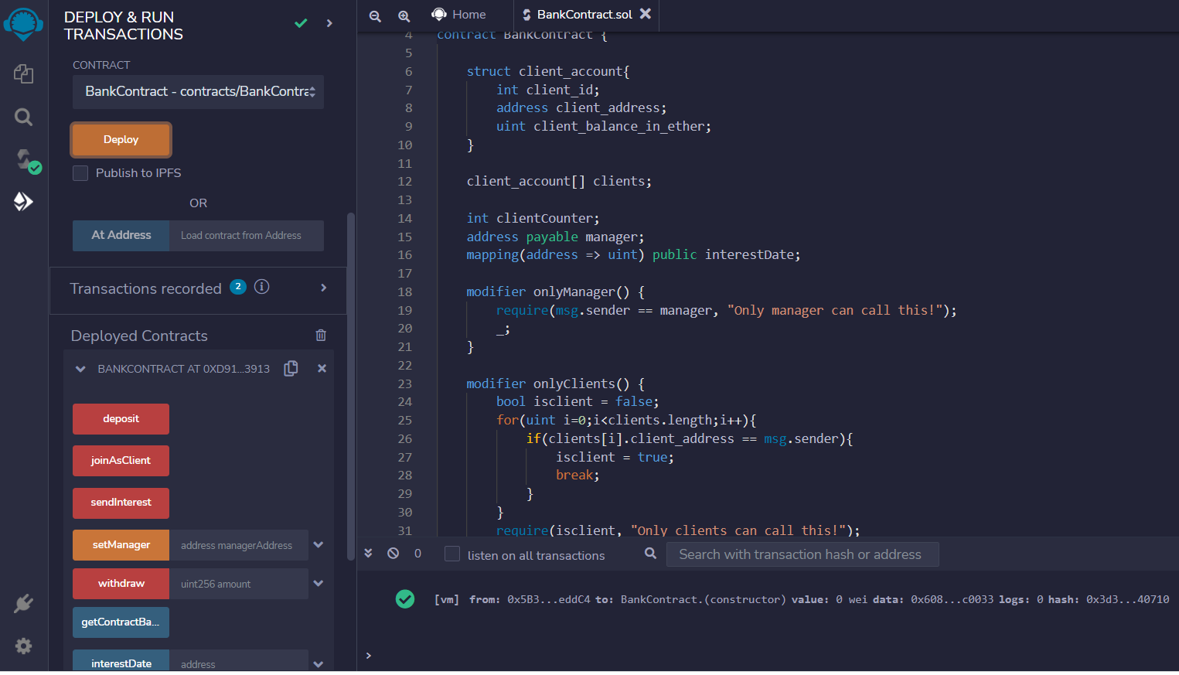
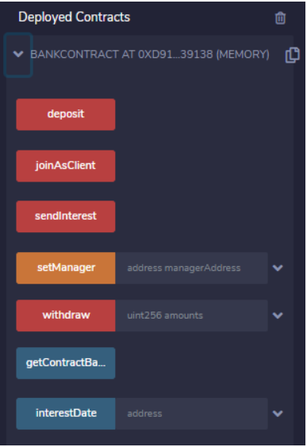
Step 3: Run the Transactions
Now, we’re ready to call the functions that compound the smart contract developed. When we expand the relevant contract in the Deployed Contract subsection, the methods developed appear.
The setManager method
We’re starting to simulate a small process by calling these methods. First, we’re supposed to set a manager. Therefore, we type an address that we select from the account combo and click the yellow setManager button. The following output happens in the terminal. The decoded output shows the message that returned from the method, which is an empty string message — as we expected.

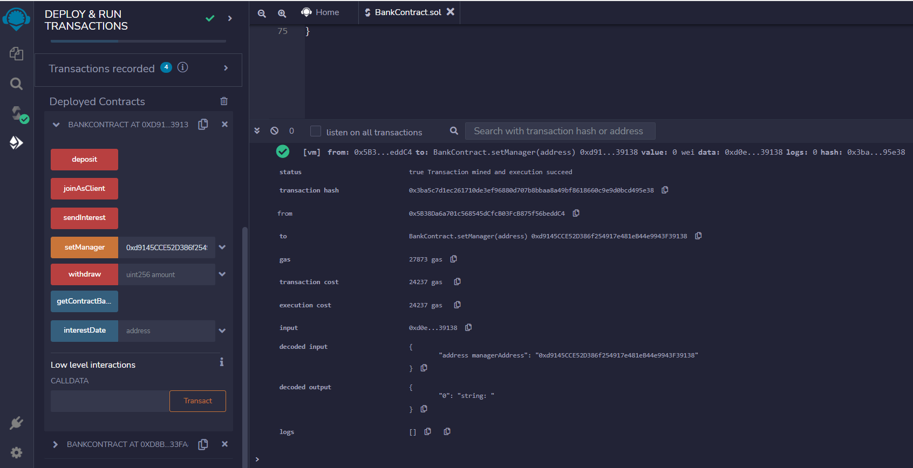
The joinAsClient method
We’ll continue to join as a client for three clients that we determined from the account combo and call the joinAsClient method for each one. At this time — and this is different from the previous one. we should call the method while selecting related accounts because we take the msg.sender value from here. Select three addresses one by one and press joinAsClient button. We get following output.
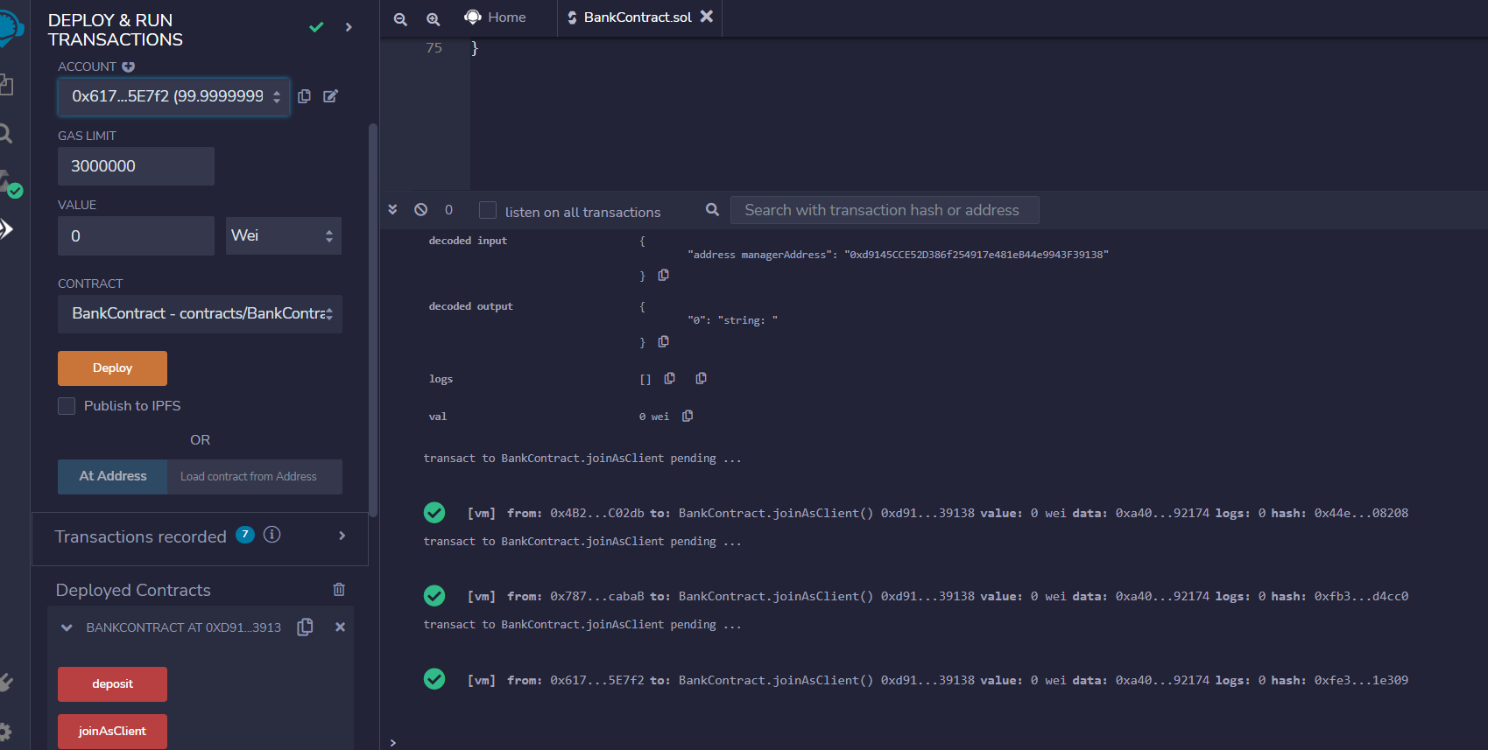
The deposit method
Now, we’ll send 10 ETH from the clients’ accounts to the contract by using the deposit method. In the deposit method, we take the amount declared in the msg.value from the sender that’s represented in the msg.sender variable. Therefore, we set 10 ETH and call the deposit method by clicking the red deposit button for each client account, like we did before for the joinAsClient method. After these operations, the following messages show in the terminal, which means those three accounts sent 10 ETH from their account to the contract address. Also, the final state of the accounts’ balances look like this: 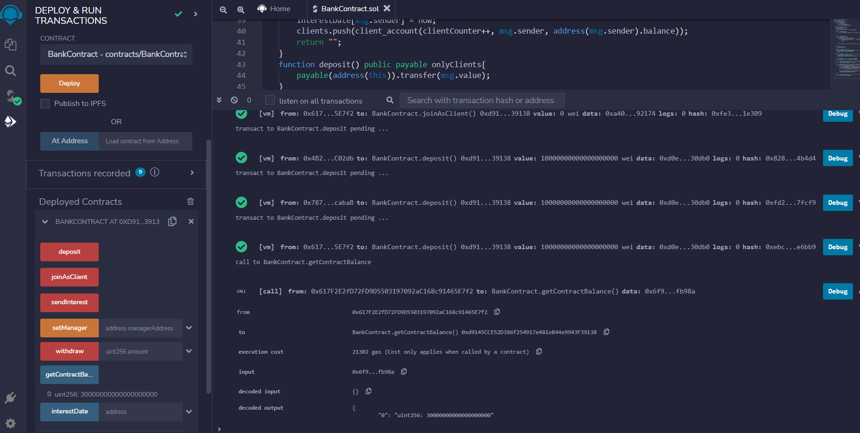

The getContractBalance method
Now, we call the getContractBalance method to check whether the 30 ETH that was sent from the clients exist in the contract account. Therefore, we click the blue getContractBalance button, and it returns an amount that corresponds to 30 ETH in Wei.
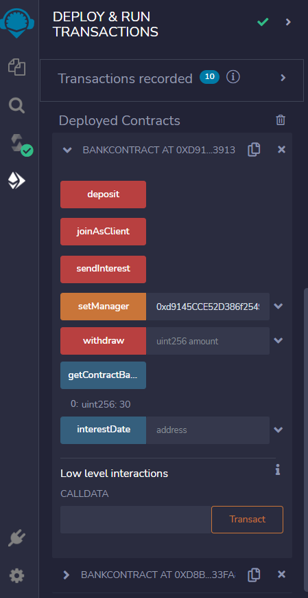
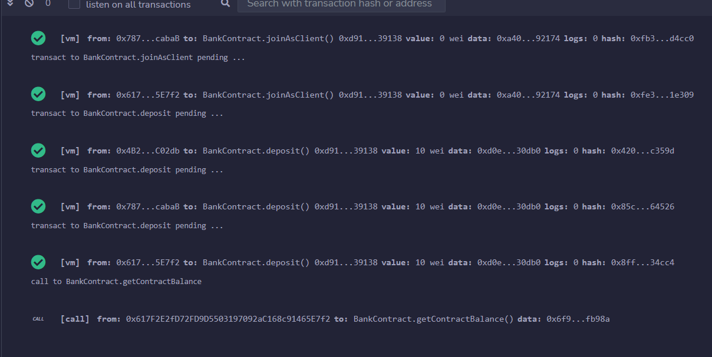

The sendInterest method
After checking that the contract isn’t empty anymore, we can send interest to our clients by calling the sendInterest method. We select the account that we’ve set as manager account before and click the red sendInterest button. The message in the image above appears after calling the method in the terminal. This message means that 1 ETH was sent to each client’s account successfully. We can see the balance of each client increased from 89 to 90 ETH after this operation.
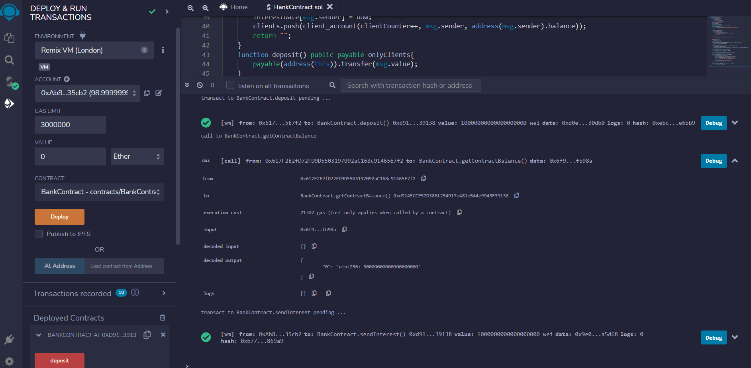
We implemented a restriction that checks whether 10 seconds have elapsed since the sendInterest method was called. To check this control, we call the same method one more time in 10 seconds. The transaction went as expected, and the "It’s just been less than 10 seconds!" message appeared in the terminal, as in the image below.
The withdraw method
Now, we call the last method we’ve developed to withdraw an amount from the contract to the client’s account. In the withdraw method, we transfer the amount declared in the msg.value from the account to the sender that’s represented in the msg.sender variable. At this point, there’s a problem realized, which is that the people who haven’t joined the contract as a client can call this method too. We use the onlyClient modifier to avoid this problem. When we select an account belonging to anyone who hasn’t joined the contract as a client and then call the withdraw method through the red withdraw button, the "Only clients can call this!" is displayed:
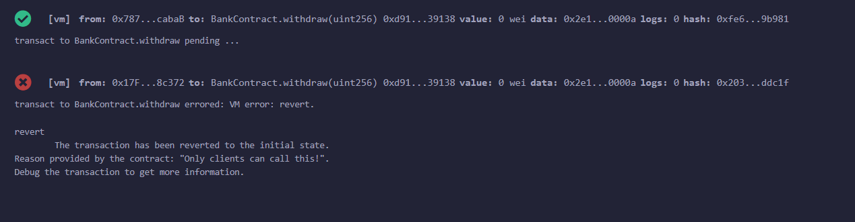
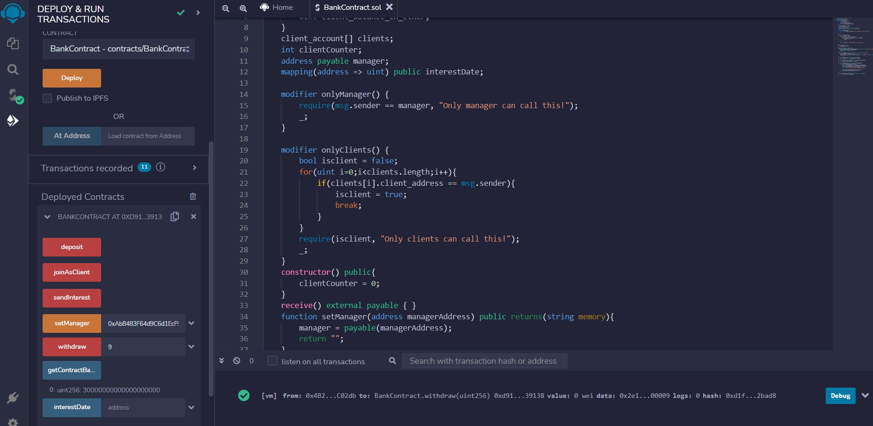

After calling the method, we see the ETH amount increased as much as we were expecting.
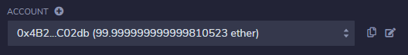
The balance of the sender
After these operations, only 18 ETH is supposed to be remaining in the contract address because a total of 12 ETH has been sent from the contract (3 ETH as interest and 9 ETH as a withdrawal). If we call the getContractBalance method, we see following result:


Conclusion
In this experiment, smart contract is successfully deployed on the Remix IDE. We tested all of the functionalities it presents by performing the transactions.
Output Secreen Shot:
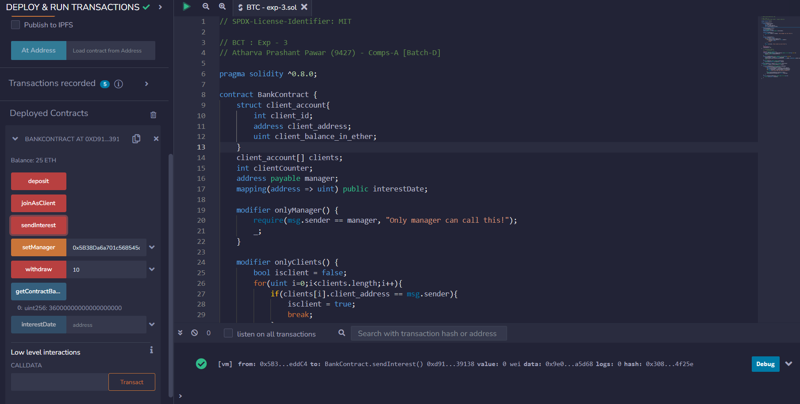
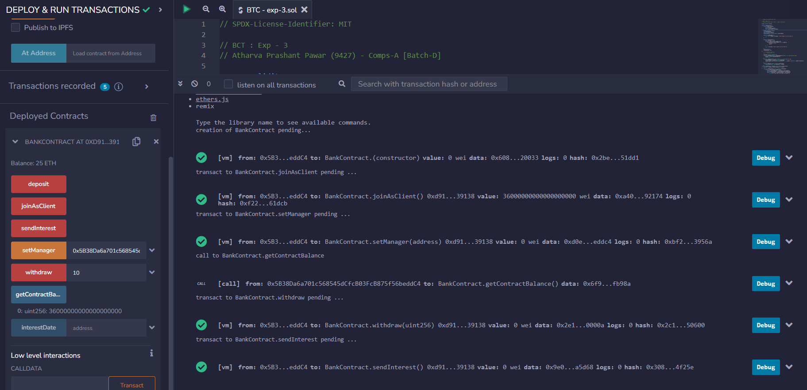
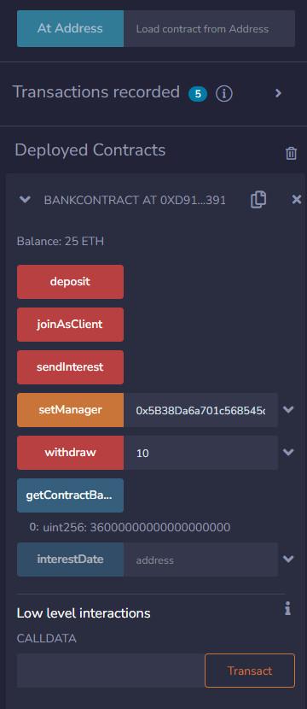
PostLab:
